ECA5602- 5g/6g communication
Slot D
K. Naga Sai Nikhil Reddy
192412553

Experiment 5: Simulation and Throughput Analysis of LTE-Advanced Carrier Aggregation
Objective 1:
Code:
clc; clear; close all;
BW1 = 20; % Component carrier bandwidth (MHz)
SE = 4; % Spectral efficiency (bits/s/Hz)
Ncc = 1; % Number of component carriers
BWagg = BW1*Ncc;
Throughput = BWagg*SE; % Mbps for MHz × bits/s/Hz
disp('Single Component Carrier')
disp(['Bandwidth = ',num2str(BWagg),' MHz'])
disp(['Estimated Throughput = ',num2str(Throughput),' Mbps'])
figure
bar(Ncc,Throughput)
grid on
xlabel('Number of Component Carriers')
ylabel('Estimated Throughput (Mbps)')
title('LTE-Advanced Single Carrier Throughput')

output:

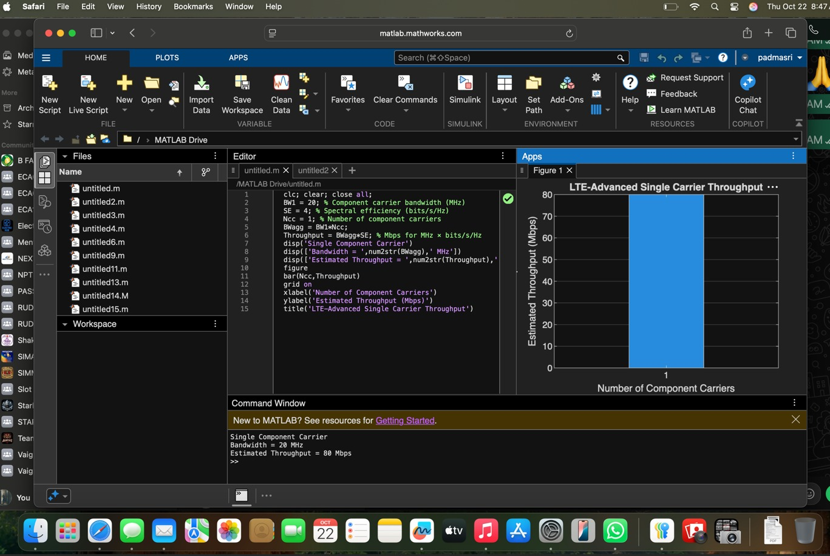

Objective 2
clc; clear; close all;
BWcc = 20; % MHz per component carrier
SE = 4; % bits/s/Hz
CC = [1 2 3]; % Number of component carriers
AggBW = BWcc .* CC; % MHz
Throughput = AggBW .* SE; % Mbps
disp('CC Aggregated BW (MHz) Estimated Throughput (Mbps)')
disp([CC' AggBW' Throughput'])

figure
bar(CC,Throughput)
grid on
xlabel('Number of Aggregated Component Carriers')
ylabel('Estimated Throughput (Mbps)')
title('LTE-Advanced Carrier Aggregation Throughput')

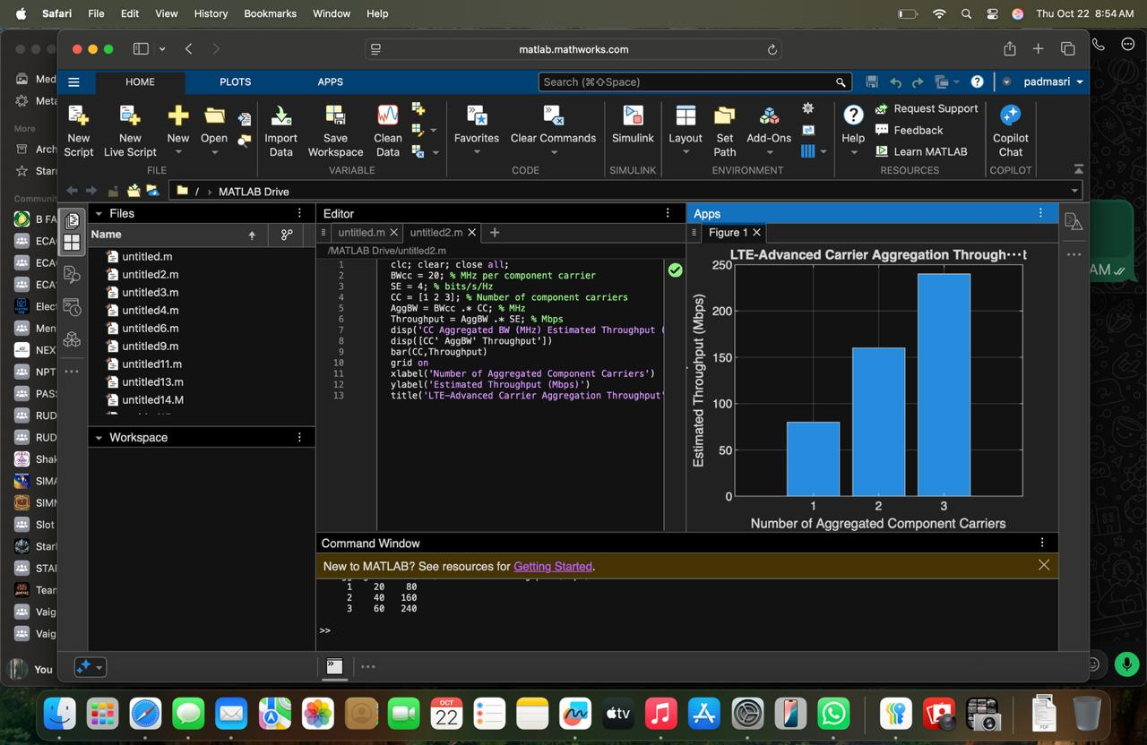

Objective 3:
Code:
clc; clear; close all;
BW = [5 10 15 20]; % Carrier bandwidths (MHz)
SE = 4; % bits/s/Hz
TP = BW .* SE; % Estimated throughput (Mbps)
disp('Bandwidth (MHz) Throughput (Mbps)')
disp([BW' TP'])

figure
plot(BW,TP,'o-','LineWidth',2)
grid on
xlabel('Carrier Bandwidth (MHz)')
ylabel('Estimated Throughput (Mbps)')
title('Throughput vs Component Carrier Bandwidth')

output:
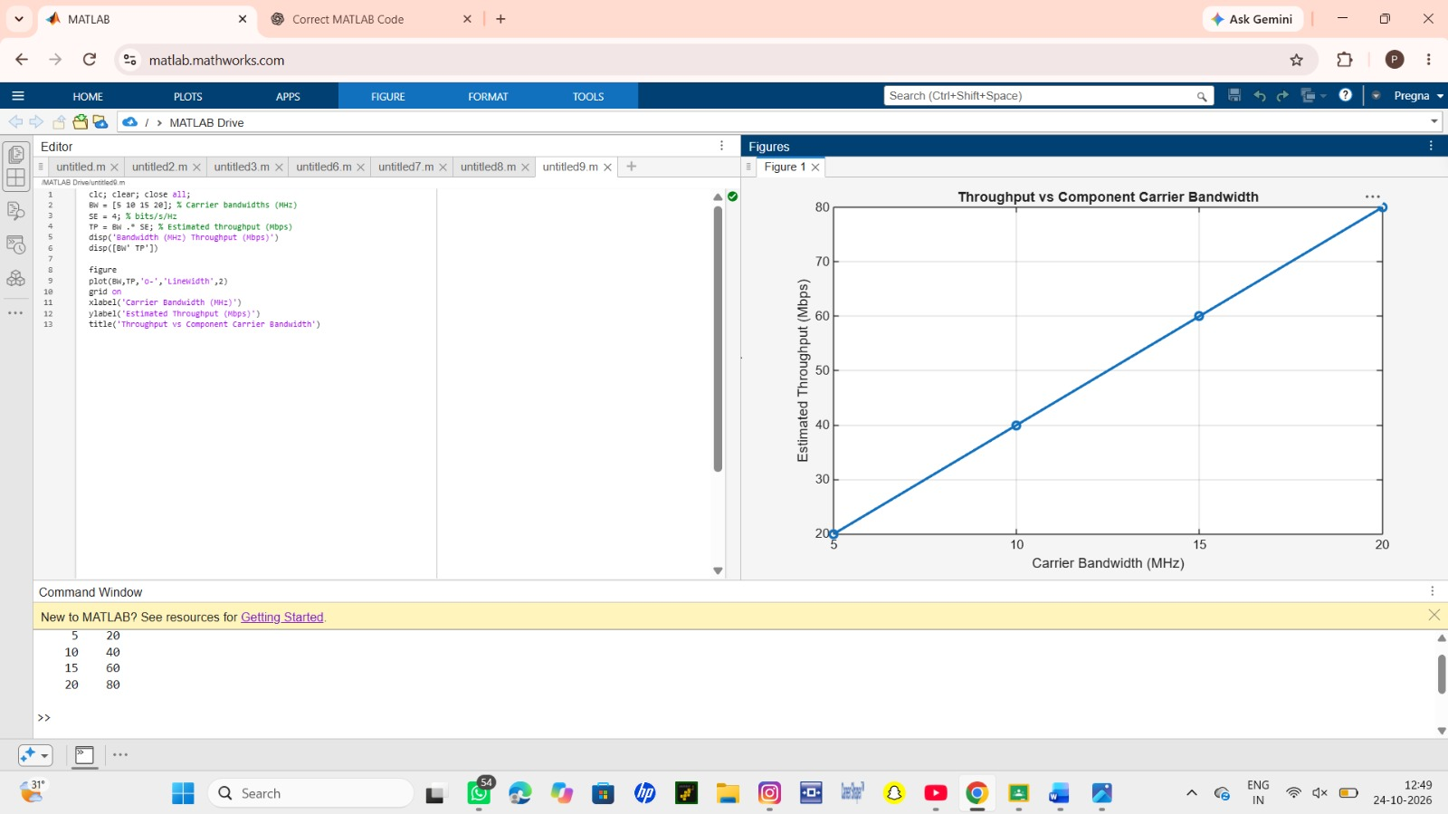
Result
1. The LTE-Advanced link was successfully modeled using a single component carrier.
2. Multiple component carriers were aggregated and the resulting bandwidth and estimated
throughput were calculated.
3. Throughput was compared for different carrier bandwidths.
4. The simulation demonstrated that carrier aggregation increases available transmission
bandwidth and can increase achievable throughput.

